Table of Contents

Introduction 3

Climate Change 3

Inherent Nature 4

Motivation 6

Objective 7

Literature Review 8

Data Visualization 8

Geographic information system (GIS) and Big Data 9

Spatial data as big data 9

Collection of Spatial Data 10

Developments in Visualization 11

Web Browsers 11

GPS Visualization Tools 13

Methods 14

Data and Data Collection 14

Analytical Tools and Evaluation Metrics 15

Visualization Process 16

Datawrapper 16

Google Maps 18

Results and Discussion 21

Large Area Generalization 21

Regional Filtering 22

Evaluation of the Visualization Tools 25

Coloring 25

Interactivity 28

Cost 31

Sharing 31

Ease of Use 32

Conclusion 33

Google Maps 33

Data Wrapper 35

References 37

Page left blank intentionally

## Abstract

The migration of animals is often considered one of the earth’s wonders. Some of the animals that migrate include some species of aquatic animals, some species of birds, crustaceans, amphibians, reptiles, insects, and mammals. With birds such as Arctic terns covering up to 44,000 miles a year, it is important to be able to track such migrations as measures with which to understand the lives of such animals. However, to do it is imperative to utilize efficient tools. The current research proposes an investigation of ways to visualize GPS data of migratory birds within a web browser using tools such as DataWrapper and Google Maps. The two tools were evaluated in terms of ease of use, quality of visualizations, and cost. Based on the findings, Google Maps was noted to provide better functionality, generated visualizations that had better quality besides being free during visualization, and with relatively low prices depending on the embedding plan adopted. As such, Google Maps was proposed for the development of a web-based migration analysis tool.

# Introduction

Migration as an adaptation? Or as an inherent nature?

## Climate Change

The last few decades have seen a dramatic shift in among various aspects of life, environmental degradation which arguably has a relatively high association with climate change (Ford, et al., 2022). In their study on the primary links between climate change and marine plastic pollution, (Ford, et al., 2022) argue that while being treated separately, the issue of plastic pollution and climate change are fundamentally linked following the role of pollutants such as plastic pollution in greenhouse emission which is a primary causal factor in climate change, that is, from the beginning to the end of its life cycle of plastic pollution (Manabe, 2019) observations that are supported by findings reported by the (Institute of Advanced Sustainability Studies, 2021) who note that air pollution, another critical scope, and climate change are closely related. The question of greenhouse emissions and hence climate change is important since the warming up of the climate due to greenhouse emissions contributes to many other changes around the world- that is, in the atmosphere, on land, as well as in the oceans (EPA, 2020).

The movement of animals is largely considered an important aspect of the ecology of various animals which can influence the fitness and the underlying species persistence through enabling activities such as foraging, predation, behavioral associations, and migration (Nathan, et al., 2008; Seebacher & Post, 2015). Migration, specifically, disrupts biodiversity at both regional and global levels, and migratory animals influence ecosystem processes (Seebacher & Post, 2015). In practice, animals tend to use predictable environmental cues in their timing as well as in navigation during migration and an upset to such cues will affect both the phenology and migratory patterns (Seebacher & Post, 2015). According to (Kristensen, et al., 2015), the arrival and hatching dates which are phenological markers in migratory birds, can be affected by changes in global warming.

## Inherent Nature

Animal migration has long been one of nature’s fascinating phenomena with animals from various taxa migrating between breeding and non-breeding areas across with variations over time and space. Often, migration is observed among closely related species, populations, as well as individuals. The question of migration had been marred with confusion. For instance, Aristotle when observing changes in bird appearances observed that birds around him changed with seasons leading him to the conclusion that “…summer redstarts turned into robins at the onset of winter, and that garden warblers became blackcaps” (Lohmann, 2018). Today, the observation by Aristotle can completely be refuted based on the evidence that such animals migrate in the observed seasons leading to the disappearance of certain birds and the appearance of others at around the same time i.e., migration.

But what drives migration? Following the fact that migration has evolved again and again among various species occupying diverse ecological niches, no single factor may be likely to explain the phenomena in all the observed cases (Lohmann, 2018). Ideally, migration especially over relatively long distances is prone to tax the underling animals in terms of energy and risk. As such, for such a behavior to keep evolving, it is to a large extent apparent that the reward in some sense is greater than the associated risks prompting the animals in question to migrate either way.

In his paper on animal migration, (Lohmann, 2018) argues that being a complex phenomenon, migration tends to involve various aspects including behavior, physiology, genetics, morphology, biomechanics, ecology as well as evolution an observation supported by (Seebacher and Post, 2015; Senner, et al., 2020) who note that climatic and environmental changes are among the lead causes of animal migration. According to (Seebacher and Post, 2015), migration tends to affect biodiversity on both regional and global scales with the migrating animals affecting various ecosystem processes.

#### Animals That Migrate

Some of the animals that migrate include Sea Turtles, Baleen Whales, Dragonflies, Wildebeests, Birds, Monarch Butterflies, Caribou, Salmon, Zooplankton, Bats, Christmas Island Red Crabs, Sharks, Tuna, and Seals (Nelson, 2020). Research shows that on average nearly 10,000 known bird species migrate including species such as “…several songbirds and seabirds, waterfowl and waders, as well as some raptors” (Priyanka, 2021). Each of the birds displays varying migratory behaviors. However, most of the birds that show such tendencies, do most of the traveling at night, an observation that (Nickens, 2013) attributes to the fact that besides being safer, at night, the ecosystem is devoid of daytime thermals, and since the atmosphere is comparatively more stable. Hence, the birds find it easier to maintain a steady course at night making it the appropriate time for bird migration (Southern Methodist University, 2019). In the article published by (Southern Methodist University, 2019), it is posited those birds are reliant on Earth's magnetic field to aid in their global navigation. Moreover, the fact that birds tend to migrate at night poses other challenges including learning the nocturnal avian migration (Nilsson, et al., 2019).

#### Storks

There are up to nineteen known species of storks including oriental stork (*Ciconia boyciana*), white stock (*Ciconia ciconia*), and black stock (*Ciconia nigra*) which are found in Europe (World Atlas, 2021). Taking into consideration the case of White storks (*Ciconia cionia*) which according to (Ramenofsky, 2010) is a migratory species whose populations breed “…extensively from the northwestern tip of Africa north through Spain and extending eastward into Europe and beyond.” After breeding, the birds return in autumn following the western and eastern routes to overwinter in the southern part of the Sahara across eastern and southern Africa. Besides, after breeding, the young birds move with adults in autumn to other overwintering sites (Ramenofsky, 2010). Even so, during the spring a few young avian returns with the adults to breed while many of the second-year birds remain in the southern Sahara and the third and much of the fourth-year birds move north during the spring season for increasing distances (Gale & Johnson, 2014) however, most neither complete the full trip nor do they breed successfully until their fifth and sixth years following their intriguing inherent delays in maturity with birds not being able to breed until they attain about 3 to 4 years (Ramenofsky, 2010).

An average journey of white storks from Europe to Sub-Saharan Africa takes about 49 days covering up to 20,000 km (Rooney, 2019). The birds then follow the Nile River to the South to eventually come to rest in different African countries such as Kenya, Sudan, and South Africa. On the other hand, the Marabou storks which are the largest birds in the stork family occur around tropical and subtropical Africa right from Zululand in northern South Africa to the Sahel region (Armistead, 2020). The white-bellied stork (*Ciconia abdimii*) (Jensen, et al., 2016) after breeding over the wet season of the Northern Tropics (*the period between May and August*), will typically move east then to West Africa or south to East Africa going through the equatorial rain-belt (between September and October) and reach in time for the South’s wet season (*between November* and *March*) (BirdLife International, 2021).

## Motivation

The current study is motivated by the need to track such migrations i.e., avian migrations. For instance, in nearly every five species of birds, at least one species has separate breeding and overwintering distributions prompting the migration of the birds under observation during such times. To this end, it is essential to be able to track such migratory patterns as a prerequisite of understanding among other factors, how the birds breed, how they socialize, etcetera. Often data related to bird migration is spatial and as a consequence, it is imperative to adopt the most appropriate analytical tools for analyzing such a phenomenon.

Further, the study is motivated by the evolution of analytical tools including the embedding of analytical results in web browsers making sharing the results of spatial data analysis easily accessible in a wide range of mediums.

### Objective

In the current work, we seek to explore the functionality of two spatial data visualization tools i.e., Google Maps and Data Wrapper in the analysis of the migratory path of storks. In particular, we intend to examine the suitability of the proposed tools in terms of but not limited to visualization quality, ease of interpretation, interactivity, and the associated weaknesses of such tools.

### Research Questions

1. What is the need for usability evaluation of different GIS applications like Google maps and DataWrapper?
2. What are the visualization options for both Google Maps and Datawrapper
3. What issues are related to the usability of Google Maps and DataWrapper?
4. Based on the proposed metrics, which is the best web-based visualization tool for the migration of birds?

## Significance of the Research

At the end of the study, it is hoped that the findings will contribute to the growing literature surrounding the use of web-based analytical tools and cloud computing. Moreover, it is hoped that the findings will provide an in-depth examination of the migration path for the birds in question (*storks*). Lastly, we hope to determine how the two tools, Google Maps, and Datawrapper perform in the visualization of avian migration paths and the kind of information the adoption of the two tools present.

# Literature Review

## Data Visualization

#### Definition

Data visualization has a rich history dating as far as the 2nd century AD (Li, 2020). Conceptually, the success of data visualization is influenced by the soundness of the fundamental idea behind it, that is, what is the original intent of the visualization being generated? (Li, 2020). Ideally, data visualization can be defined as “the presentation of data in a pictorial or graphical format, while a data visualization tool is the software that generates this presentation” (Bikakis, 2018). More recent developments in the field of visualization software development include the development of tools that can generate visual insights from big data (Bikakis, 2018). Often, data visualization can be categorized into Static Versus Interactive Visualizations also defined as Static Infographics vs. Interactive Infographics (Sonnenberg, 2020; Yuk and Diamond, 2020).

From satellite data to GPS locations, the importance of spatial data is undeniable and with the growth in popularity of technologies like Facebook tags, Yelp check-in, Uber routes, etcetera, spatial data has become an integral part of day-to-day life (Ghosh, 2019). Based on the significance of the spatial data in understanding various aspects of human life, (Ghosh, 2019) argues that the interactive visualization of spatial datasets can be of great significance to the scientific community in enabling “…exploratory analytics which in turn helps to identify unique patterns and trends.” The key point, *interactive visualization*. At the very basic, interactive visualization refers to the use of software that allows direct actions to modify elements on a graphical plot enabling the generation of more comprehensive insights as opposed to static visualizations where the user gets insights that the analyst chooses to present (Yuk and Diamond, 2020). Therefore in practice, interactive visualizations are more informative compared to static infographics hence more suitable for aspects such as the visualization of spatial data.

## Geographic information system (GIS) and Big Data

(Ki, 2018) observe that over time, GIS has expanded its fields of applications and services to include several fields such as geo-positioning service, three-dimensional demonstrations as well as virtual reality. In an article published by (Esri, 2021), GIS is identified as a framework for gathering, managing, and analyzing data and in particular, data related to spatial locations allowing the generation of insights such as patterns, relationships, and situations. With regard to the question about the linkage between big data GIS, (Ki, 2018) examines how big data tools can be integrated to enable visual analysis of spatial data. Big data is characterized by “3V” denoting volume, variety, and velocity (Jeong, 2012). Perhaps, understanding how spatial data fits in the concept of big data will help shed light on how to adopt big data visualization tools in the visualization of migratory spatial data.

### Spatial data as big data

Surprisingly or rather non-surprisingly due to the increase of technologies that utilize spatial data, a significant amount of big data is spatial data with research showing that spatial data is growing at a rate of about 20% per year (Dasgupta, 2013). That is, in some sense, geospatial data has always been big data (Lee and Kang, 2015). The estimation by (Dasgupta, 2013) however did not include spatial data in private archives and data from RFID sensors. The components of spatial data include an overview indicating the purpose and proposed usage, as well as the specific quality elements detailing the lineage, positional accuracy, attribute accuracy, logical consistency as well as completeness of the data (Statistics Canada, 2018). Similarly, spatial data as observed by (Janipella and Moharir, 2019), consists of the relative geographic information regarding the earth and its features. In that, a pair of latitude and longitude coordinates denote a specific location on earth and can be categorized as either raster data or vector data depending on the techniques used during storing.

#### Vector data

When it comes to spatial data, most individuals tend to think of vector data (Romeijn, 2020). Conceptually, vector spatial data comprises points, lines, or polygons and at its basic level, such data consists of individual points stored as coordinate pairs that refer to a physical location in the world (Romeijn, 2020). Therefore, vector data is significant in building systems that require data with discrete boundaries such as streets, location points, and so on.

#### Raster Data

Raster data on the other hand allows a “…representation of the world as a surface divided up into a regular grid array, or cells, where each of these cells has an associated value” (Romeijn, 2020). Such data include representations of spatial data in terms of elements like digital photographs or satellite images where each cell is identified as a pixel which ultimately corresponds to a value of a particular data.

Previous studies posit that bird migration can generally be stored as distribution polygons that generally denote the coarse generalizations of the distribution of different avian species’ which are derived from the locations of known records (Somveille, et al., 2013) i.e., avian migration is mostly stored as vector data. Therefore, when examining how to visualize bird migration one ought to consider the use of visualization tools that enable the visualization of vector geographical information.

### Collection of Spatial Data

Several modern tools have been specifically developed for the collection of spatial data which has traditionally been collected through mapping data in the field some of which include global positioning system (GPS) receivers (Keeler and Emch, 2017), raster digital elevation model (DEM) (Oguchi, et al., 2011) etcetera. The current study is proposed to utilize spatial data collected from GPS tools. Studies that use GPS data to track bird migration include (Richie, 2021) which proposes that in an era of high-tech tracking equipment as well as global cooperation, it is possible to explore the locations of birds as small as swallows from breeding and wintering grounds, from stopovers and long migrations.

According to (Pancerasa, et al., 2019), geolocators are advanced technological tools that can be used to reconstruct the migration routes of animals that might be too small to carry satellite tags (such as passerine birds). The argument by (Pancerasa, et al., 2019) is supported in a study by (Sessa-Hawkins, 2019) which uses GPS data to develop a web-based tracker (i.e., Euro Bird Portal’s LIVE viewer) for the movement of birds named. essentially

## Developments in Visualization

While the question of visualization of spatial data can raise the concern of whether spatial data visualization is not essentially cartography, the answer is, visualization of spatial data is and it is not cartography thanks to considerably new developments in the landscape of making and using maps (Dempsey, 2017). Some of the most notable developments in the field of spatial data visualization include data democratization, Cloud Computing Services, Data Warehouses, and Light detection and ranging (Lidar) (GeoCTRL, 2020). Other developments include the embedding of visualizations in web browsers (Lu, et al., 2013), and developing spatial visualizations in Augmented reality (AR) (Zollmann, et al., 2012).

### Web Browsers

Up until 2015, Web-based geographic information systems (WebGIS) were relatively young in terms of the underlying interfaces and functionality (Qiu and Huang, 2015) but later years have seen substantial changes in the integration of spatial data analysis on web browsers (Yakubailik, et al., 2018) due to the availability of new tools such as Open Geospatial Consortium (OGC) protocols that entail methods like Web Map Service (WMS), Web Map Tiling Service (WMTS) etcetera (Yakubailik, et al., 2018). According to (Yakubailik, et al., 2018) the Open Geospatial Consortium (OGC) protocols support the access of geoportal resources by user-based programs such as ArcGIS, MapInfo, QGIS etcetera since the support of these tools is included in most modern GISs.

Primarily, the evolution of web standards distributions from Web 2.0, HTML4 to the current HTML5, which allows plugin-free multimedia support, whilst keeping the content consistently understood by computers (Qiu and Huang, 2015) is among the central factors that have influenced the growth in popularity of associated technologies in which web-based analyses are conducted. Previously, it was observed that spatial data can be divided into raster and vector.

In practice, raster data, whose sources include among others, satellite images, denote the world as a surface that is split into a regular grid of cells. On the other hand, vector data denote the world as a surface that is jumbled up with recognizable spatial objects. Such objects can be denoted as points, lines, or polygons (Qiu and Huang, 2015). HTML4 has inherent support of data with raster formats including JPEG, GIF, and PNG making it easy to include raster data on the web. However, in the case of vector data, HTML4 based browsers require the use of plugins such as Flash which was most recently discontinued by Adobe (Brookes, 2021), and SVG which might lead to compatibility problems whenever there is a future need to access the spatial visualizations of Vector data in other web browsers (Qiu and Huang, 2015).

With the development of HTML5, there is an introduction of more graphical tools that are suited to address the challenges of vector data visualization in current WebGIS. In their paper on the effective vector data transmission as well as visualization in HTML5-based applications, (Corcoran, et al., 2011) suppose that HTML5 presents a novel WebSocket API that elucidates a full-duplex communication channel between the client and the server. Essentially what this does is provide improved data communication both in terms of bandwidth utilization as well as network latency relative to technologies such as Web 2.0 and HTML 5 among other push applications.

## GPS Visualization Tools

(Jager, 2017) argues that some of the visualization tools for map representations include Google Maps and Google Earth, Someka Heat Maps, Tableau, OpenHeatMap, ArcGIS, Polymaps, Target Map, InstantAtlas. Other equally useful tools as identified in (Spatial Vision, 2021) are Plotly, Flourish, DataWrapper, DataMatic, Infogram, Microsoft Power BI, and Kepler. As proposed earlier, the current study is inclined towards the exploration of Google Maps and DataWrapper as map representations tools. That is, the current study seeks to examine the suitability of both Google Maps and Datawrapper as web-based migration visualization tools.

# Methods

The current work adopts a quantitative research methodology using a data visualization design methodology which is implemented by combining a number of in-depth quantitative comparisons between various map representation tools that focus on the visualization of spatial data. The methodology is essentially defined such that it is flexible and the results obtained as a result of the completion of the research will be dependent on how well the respective tools perform among other metrics that will be proposed.

## Data and Data Collection

Table 1 below provides an overview of the general characteristics of the data that will be used in the current study.

Table 1: Data characteristics

|  |  |
| --- | --- |
| Data Aspect | Observation |
| Number of attributes | 8 |
| Number of observations | 9896 |
| Variables in the data | Speed Kph, Speed_Reference_Kph, Speed Mph, Hdop, Latitude Float, Longitude Float, Latlong Marginin Meters, Latlong Marginin Feet |

Data used in this study is related to the migration of the storks south of Africa’s Sahara. While the data does not include the direction of movement, it includes sufficient information to enable us to understand when the birds were in the movement and the locations where they perched i.e., where the speed of movement was 0.0 Kph.

#### Data preprocessing

The data preprocessing was influenced by the type of variables that are contained in the data. For instance, both spatial data visualization tools require the specification of the longitude and latitude attributes in addition to the third option of including regional markets in google Maps. The data were examined for missing observations with the option of imputing using the mean if any.

Figure 1 below provides an overview of the visualization workflow.

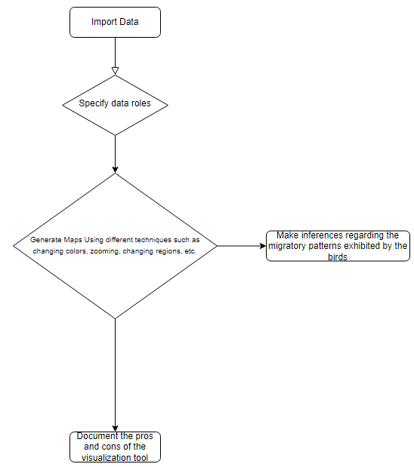

Figure 1: Data visualization workflow

### Analytical Tools and Evaluation Metrics

Both Google Maps and DataWrapper are proposed for use in the research. The following subsections explore the pros and cons of the two tools using metrics such as learnability, cost, efficiency, ease of use, errors, and the quality of the underlying presentations/ satisfaction (Khan and Adnan, 2010). During experimentation, the tools are evaluated in terms of learnability, efficiency, ease of use, and quality of the visualizations that are developed. We seek to examine how the pros and cons stack up against the actual performance of the tools using actual data.

Ideally, we will generate visualization from a broader perspective i.e., world mapping, and narrow it down to finer details to include regions, streets, landmarks etcetera depending on the capability of the visualization tools. This will allow us to examine how well the tools provide generalizations regarding the migration of birds.

## Visualization Process

In this section, we provide an in-depth examination of the visualization process for both the Data Wrapper and Google Maps tools.

### Datawrapper

#### Steps

Generating maps in Datawrapper follows 4 basic steps (*see figure 2*).

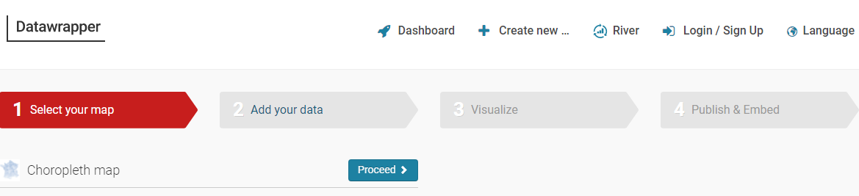

Figure 2: General visualization steps in Datawrapper

1. Selecting your map - In this step, we are prompted to select the map that we would like to use. That is, how refined do we want our map. For instance, by selecting the world, we will plot our data over the world map, and by selecting a specific region say African continent, assuming we know the area span by the data, we will refine the visualization to the African continent. Following a preliminary visualization, we noted that the data spans over locations in West Africa. Therefore, in our case, the refinement is conducted over three categories i.e., World, Africa, and West Africa.

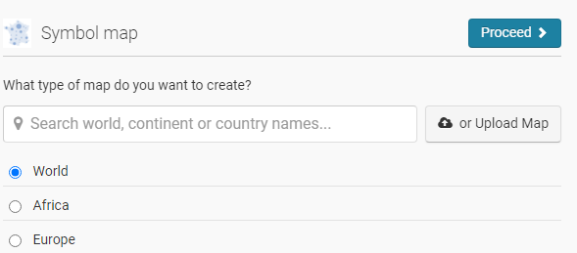

Figure 3

1. Add your data - Here we upload the data and conduct all the preprocessing that is required including defining the role of the variables in the data. Since our focus is Latitude and Longitude as well the speed, we will subset the data to include the attributes *Speed Kph, Latitude Float,* and *Longitude Float*.

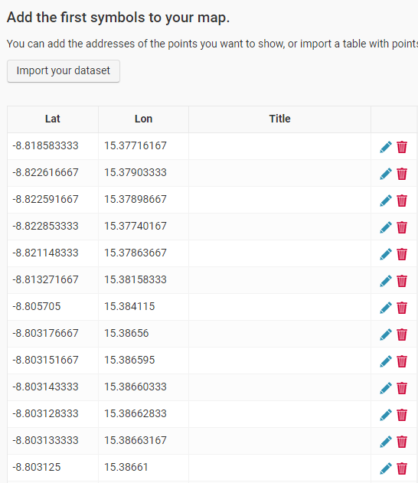

Figure 4

1. Visualize – this step includes generating visualizations regarding the movement of the storks
2. Publish and embed – lastly, Datawrapper gives us an option to publish the resulting visualization and embed it in our website.

#### Assumptions

1. We assumed that the first row of the data corresponds to the point where the birds began migrating to the destination point.
2. The last point in the data is the final destination
3. The speed of the birds is 0 Kph when they have perched be it for food or rest.
4. The entry with longitude 0 and latitude 0 is an outlier hence it was excluded.

### Google Maps

The process of visualization in Google Maps follows the following steps:

1. Selecting the product, we want to use in our case, we will use *your places* product which allows you to visualize the places “you have visited”

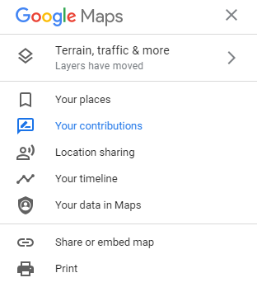

Figure 5: Step 1- Selecting the product to use

1. Second, we need to generate a map, we will therefore select the *Maps* product (*see figure 6*).



Figure 6: Select the maps

1. After selecting the map product, we will further select the *create map* option.

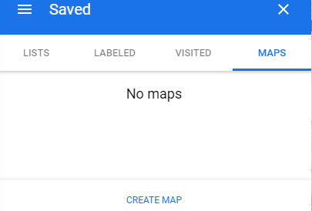

Figure 7: Option to create a new map

1. Import data to visualize – in this step, we import the data and preprocess it by specifying the roles of the attributes.

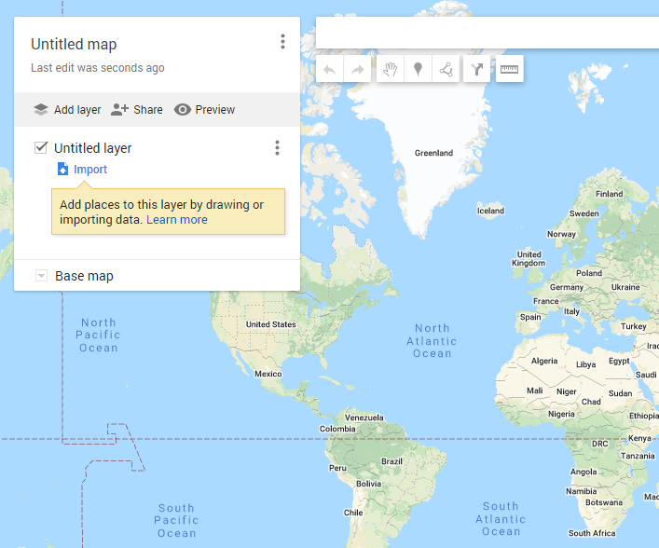

Figure 8: Overview of the data importation layer

1. Define the function of each attribute – here we defined the latitude, longitude, and point attributes (*see figure 9*).

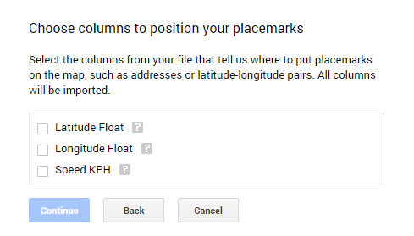

Figure 9

# Results and Discussion

The following section provides an overview of the migration path visualization by both tools of different levels.

## Large Area Generalization

Figures 10 and 11 below show the large area visualization of the migration of the storks using Google Maps and Datawrapper respectively.

##### Google Maps

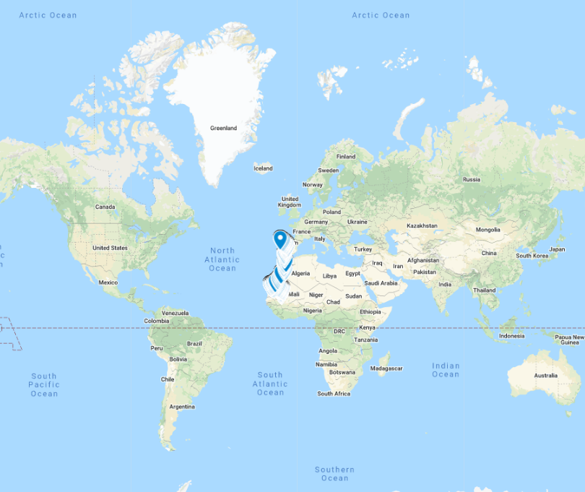

Figure 10: General overview of the migration path using Google Maps

From figures 10 and 11 we note that the migratory path of the storks is set in West Africa through to Portugal.

#### Datawrapper

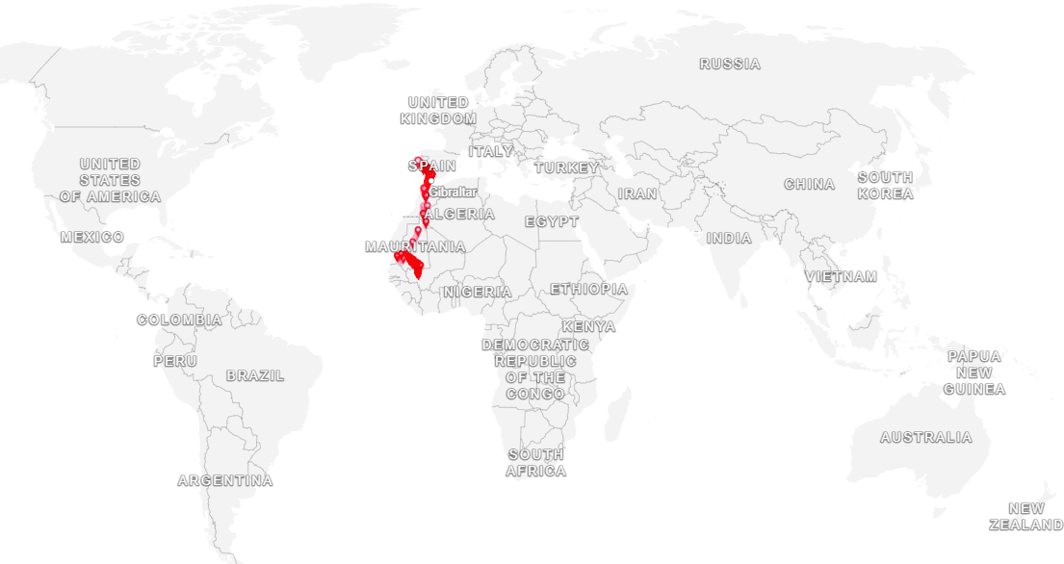

Figure 11: General overview of the migration path using Datawrapper

## Regional Filtering

Figure 12 below shows a more refined map using Google Maps. The birds are noted to have traversed different countries including:

1. Mali – Point of origin
2. Mauritania – Central Mauritania
3. Algeria – Western Algeria
4. Morocco – Central Morocco
5. Gibraltar
6. Spain – South West Spain
7. Portugal – South West Portugal: Point of Destination

#### Google Maps

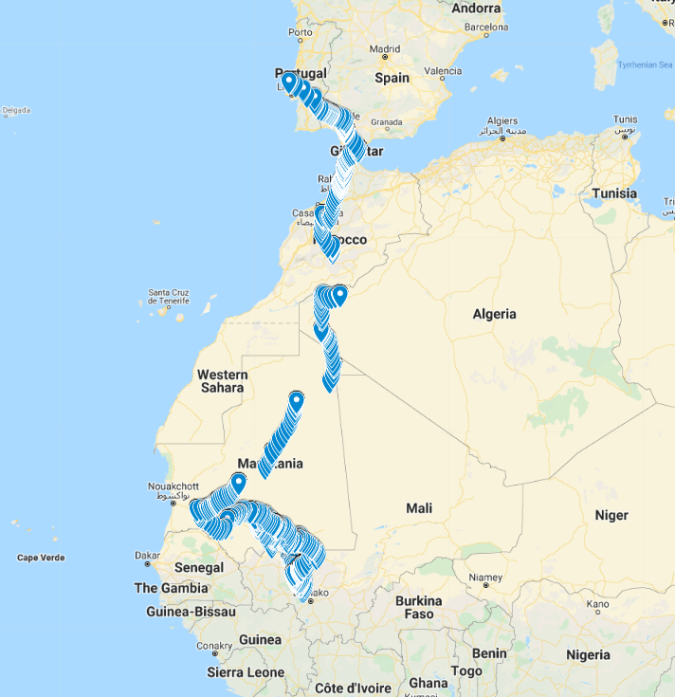

Figure 12

Overall, we noted that while Datawrapper allows the definition of the size of markers by speed, Google Maps allows examination of the various attributes of locations by hovering over the underlying location. For instance, from figure 13 below we note that at the beginning of the migration, using Google Maps, the birds traveled at 46.82 Kph while at the end of migration, the birds traveled at a speed of 0 Kph (*see figure 14*).

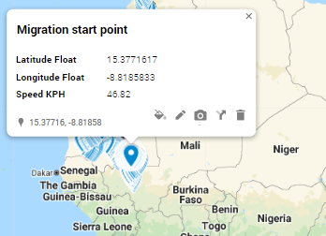

Figure 13

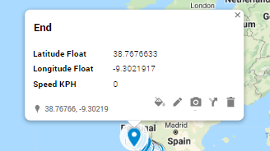

Figure 14

Using Datawrapper, we were able to explore how the speed changed during the entire migration path (*see figure 15*).

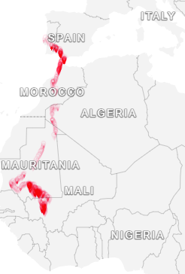

Figure 15: Change of speed during migration

From figure 15 above we note that the speed of the birds is relatively high at the beginning of the migration but slows between Central Mauritania and Morocco. The speed later increases as the birds cross the Tangier through Gibraltar and Spain after which the speed decreases as the birds enter Portugal.

## Evaluation of the Visualization Tools

The following subsections provide a review regarding how the visualization tools perform based on the specified metrics.

### Coloring

As shown in figure 16 Datawrapper offers 5 coloring options based on assumed color blindness which is in contrast with the 9 base map options provided by Google Maps (*see figure 17*).

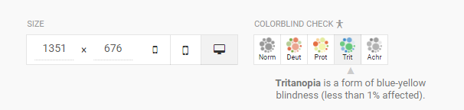

Figure 16: Visualization coloring options in Datawrapper

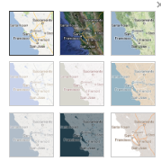

Figure 17: Visualization options in Google Maps

In practice, we found that the base map options provide better visualizations compared to the color blind option provided by Datawrapper. For instance, figures 18 and 19 below show maps generated using the *Trit* option in Datawrapper which we observed during the trials as the best option for Datawrapper (in this case “best” is subjective) and the *satellite* option in the base map as provided by Google Maps respectively.

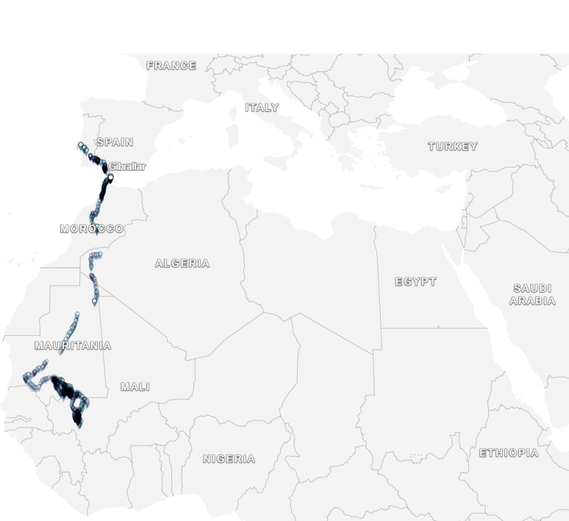

Figure 18: Best Datawrapper migratory map

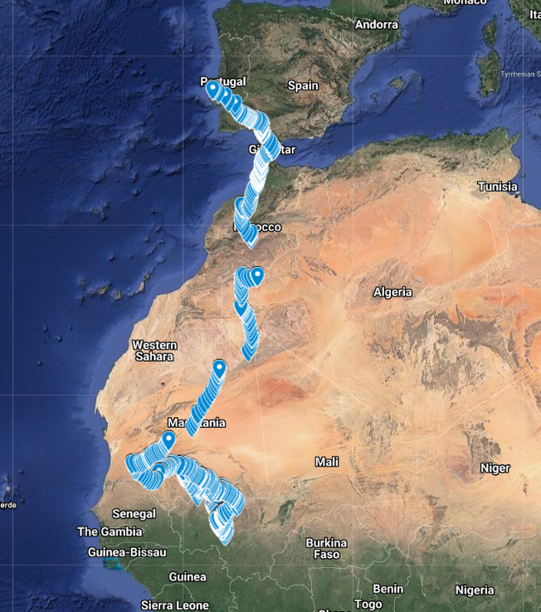

Figure 19: Best Google Map

The terrain option also produced a beautiful plot as shown in figure 20. Ideally, the terrain plot shows the elevation along a path

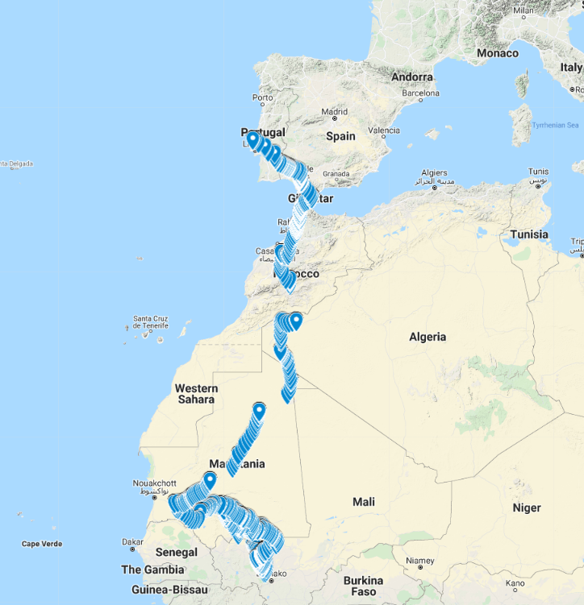

Figure 20

### Interactivity

Interactivity was measured based on the details that can be determined by hovering and zooming.

Datawrapper allows highlighting of data points by hovering over the legend. For instance, from figures 21 and 22 below we can determine the points where the speed of the birds was 104.0 Kph and 15.0 Kph.

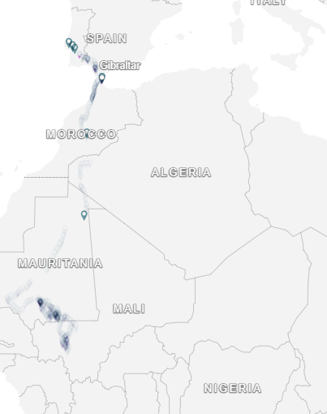

Figure 21: Hovering over the legend in Datawrapper

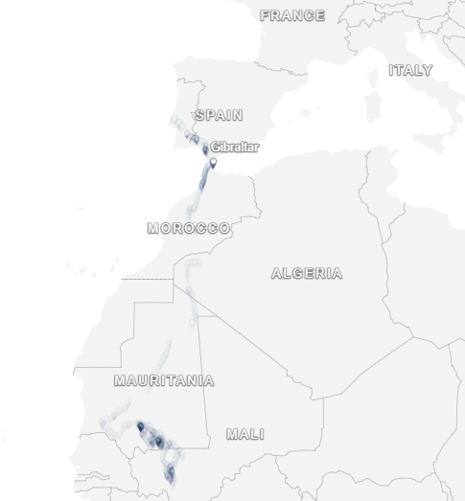

Figure 22: Points where the birds were flying at 15.0 Kph

Hovering on Google Maps required that we click on the point whose information we would like to extract (*see figure 23*).

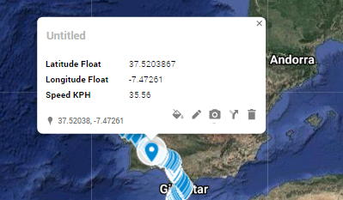

Figure 23: Google Map hovering

We noted that whereas both tools allow zooming, Google Map had better responsiveness to zooming by refining the details better relative to DataWrapper. For instance, figures 24 and 25 show the migration path over Mauritania for both Datawrapper and Google Maps respectively.

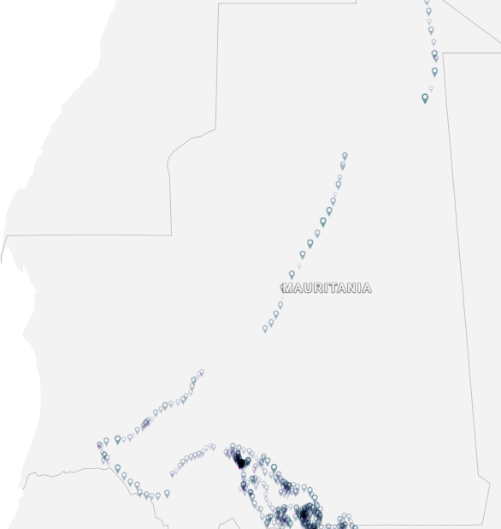

Figure 24: Datawrapper

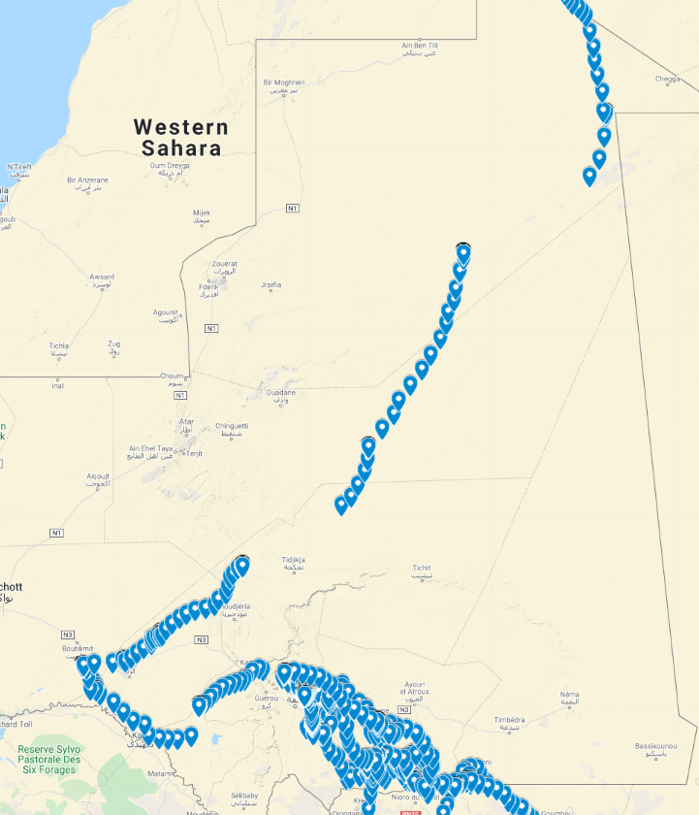

Figure 25

### Cost

All the visuals generated for this research regarding both the Datawrapper and Google Maps were primarily free. However, Datawrapper unlike Google Maps required that we upgrade to access additional functionality of the tool including customization of the theme etcetera.

### Sharing

Each of the tools provided an option for embedding the maps that were generated on a website. However, the tools have different plans regarding pricing in cases where the visualizations are embedded. For instance, the Datawrapper tool, to embed the resulting visualizations one has to subscribe to the enterprise plan which allows for self-hosting which costs over 499€ per month depending on the size of the organization. Google Maps on the other hand allows embedding but if the embed option is advanced, has static maps, or has dynamic maps, one has to pay $14.00 for up to 14,000 loads, $2.00 for up to 100,000 loads, and $7.00 for up to 28,000 loads for the advanced, static maps, or dynamic maps embeddings respectively.

### Ease of Use

Based on our experience while experimenting with both tools, we noted that Google Maps generally provides an easier-to-use interface, especially during role allocation and visualization compared to Datawrapper. Besides, the process of zooming is more fluid in Google Maps than in Datawrapper.

# Conclusion

At the very least, migration is an interesting phenomenon. It allows us to understand the behavior of the migratory animals in question including aspects such as the breeding process, feeding, among other adaptation mechanisms of the animals. The current study sought to examine the suitability of two spatial data visualization tools i.e., Google Maps and Datawrapper as a means of understanding the paths followed by Storks right from their original habitat to new habitats.

Based on our findings, we noted that the storks whose migration pattern was studied in the current work migrate from West Africa in Mali, traversing up to seven countries to Europe in Portugal. The question of how the animals track their path besides crossing a sea to reach another continent is fascinating but the primary question lies in what causes the migration. Past literature argues that in the case of White storks (*Ciconia cionia*) which according to (Ramenofsky, 2010) is a migratory species whose populations breed “…extensively from the northwestern tip of Africa north through Spain and extending eastward into Europe and beyond.”

Moreover, we observed the following advantages and disadvantages of the tools.

### Google Maps

#### Advantages

##### In-depth Information

Google maps include information such as the layout of roads, locations of different cities and towns, state boundaries, extensive geographical features, satellite images, etc. making it suitable for use in cases where in-depth details regarding bird migration are required (Papiewski, 2020).

##### Sharing

GPS visualizations generated by Google Maps can be shared on several channels including websites, blogs, social media sites such as Facebook and WhatsApp (Storm, 2011) which is in line with the proposed research that proposes the use of web-based GPS visualization tools.

##### Interactive Maps

Google Maps enables users to switch between several map representations from satellite to the traditionally conventional map (Graham, et al., 2011). The tool further allows examination of terrain details to be greater in-depth hence enabling better interpretations of the results thus improving our understanding of the migration patterns.

##### Cost

The generation of maps was largely free except when a developer chooses a different embedding plan where one has to pay $14.00 for up to 14,000 loads, $2.00 for up to 100,000 loads, and $7.00 for up to 28,000 loads for the advanced, static maps, or dynamic maps embeddings respectively.

#### Limitations

##### Limited Accuracy

Information provided by Google maps may include errors due to the ambiguities and flaws in location data (Plantin, 2018). However, since the research is expected to use individual data, the error margins are expected to be minimized.

##### Cost

While developing web-based analytical tools using Google Maps API is to a large extent free, events where a high amount of traffic is generated, the developers will incur additional costs for excessive loads (Gilmore, 2015).

##### Ease of use and interpretability

According to (Gilmore, 2015), as a web-based data visualization tool, Google maps requires the analyst to have some programming knowledge making its use relatively difficult for users without such knowledge. However, the resulting visualizations are easy to interpret as we have established in the preceding section.

##### Lack of additional roles

Compared to Datawrapper which allowed us to analyze the migratory path based on speed, an additional attribute, Google Maps only allowed us to define the start and endpoints of the migration path but there was no option to visualize the path based on speed.

### Data Wrapper

#### Advantages

##### Sharing

Typically, DataWrapper is a web-based visualization analytical tool implying that for every visualization, DataWrapper generates a URL and an embed code that can be used to share the resulting visualization in any web browser (VizE Lab, 2021). Primarily this implies that the results of the tool’s visualization process can be accessed from multiple platforms.

##### Interactive maps

An article published in (VizE Lab, 2021) defines the tool as “…a free online platform that helps users easily create interactive charts, maps, or table” i.e., the tool generates interactive visualizations that allow the user to interact with the resulting maps thus generating deeper insights than static maps.

##### Cost

DataWrapper offered us up to three usage options including a free option where the user can publish unlimited visualization, and export the visualizations as PNG files. The tool also offers a custom option that allows full design documentation, exploring of the visualizations as PNG, SVG, and PDF with an inclusion of 10 user licenses at 599$ per month as well as an enterprise plan for enterprise usage (Datawrapper, 2021).

##### Ease of use and interpretability

In addition to the ease of interpreting the visualizations generated by DataWrapper, the tool does not necessitate that the analyst should have programming or technical knowledge making it suitable for use by a large audience (Sharma, 2021).

Besides, Datawrapper provides an option to filter the area that we would like to visualize i.e., world, continent, country, etcetera.

#### Limitations

Some of the limitations inherent with the tool as observed by (Sharma, 2021)include:

1. The tool does not allow us to define map aspects such as satellite view or terrain view.
2. Since there is no option to generate custom colors and fonts, it is difficult to customize the features of the visualizations generated by DataWrapper
3. The structure of the analysis that can be done using the tool is defined by the tool making it lack flexibility with visuals.
4. The tool’s coloring is quite basic compared to Google Maps

Following our findings and the comparison metrics that were proposed for evaluating the suitability of the two tools, we can argue that Google Maps is a fairly better tool for the development of a web-based analysis tool for avian migration.

# References

Abbruzzo, A., Ferrante, M. & Cantis, S. D., 2021. A pre-processing and network analysis of GPS tracking data. *Spatial Economic Analysis,* 16(2).

Armistead, G., 2020. *THE STORKS OF AFRICA,* s.l.: RockJumper.

Bikakis, N., 2018. *Big Data Visualization Tools,* Greece: ATHENA Research Center.

BirdLife International, 2021. *Species factsheet: Ciconia abdimii.,* s.l.: BirdLife International.

Brookes, T., 2021. *Adobe Flash is Dead: Here’s What That Means.* [Online]   
Available at: https://www.howtogeek.com/700229/adobe-flash-is-dead%C2%A0heres-what-that-means/#:~:text=Flash%20is%20Going%20Away%20Forever,altogether%20on%20January%2012%2C%202021.&text=This%20also%20means%20that%20versions,Google%20Chrome%20will%20be%20retired.  
[Accessed 02 May 2021].

Corcoran, P., Mooney, P., Winstanley, A. & Bertolotto, M., 2011. *Effective Vector Data Transmission and Visualization Using HTML5,* s.l.: s.n.

Dasgupta, ]. A., 2013. *Big data: the future is in analytics.* [Online]   
Available at: http://www.geospatialworld.net/Magazine/MArticleView.aspx?aid=30512  
[Accessed 31 May 2021].

Datawrapper, 2021. *Fitting plans for teams of every size..* [Online]   
Available at: https://www.datawrapper.de/pricing  
[Accessed 02 June 2021].

Dempsey, C., 2017. *Types of GIS Data Explored: Vector and Raster,* s.l.: GIS Lounge.

EPA, 2020. *Climate Change Indicators: Greenhouse Gases,* s.l.: United States Environmental Protection Agency.

Esri, 2021. *What is GIS?.* [Online]   
Available at: https://www.esri.com/en-us/what-is-gis/overview [Accessed 31 May 2021].

Ford, H. V. et al., 2022. The fundamental links between climate change and marine plastic pollution. *Science of The Total Environment,* 806(1).

Gale, P. & Johnson, N., 2014. The Role of Birds in the Spread of West Nile Virus. In: N. Johnson, ed. *The Role of Animals in Emerging Viral Diseases.* s.l.:Academic Press, pp. 143-167.

GeoCTRL, 2020. *Four Geospatial Analytic trends of 2021,* s.l.: GeoCTRL.

Ghosh, S., 2019. *Interactive Visualization For Big Spatial Data.* s.l., SIGMOD '19: Proceedings of the 2019 International Conference on Management of Data, pp. 1826-1828.

Gilmore, J., 2015. *Integrating Google Maps into Your Web Applications,* s.l.: developer.com.

Graham, S. R., Carlton, C., Gaede, D. & Jamison, B., 2011. The Benefits of Using Geographic Information Systems as a Community Assessment Tool. *Public Health Rep,* 126(2), p. 298–303.

Institute of Advanced Sustainability Studies, 2021. *Air Pollution and Climate Change,* s.l.: Institute of Advanced Sustainability Studies.

Jager, T., 2017. *Eight effective and useful data visualization tools for mapping,* s.l.: bigdata-madesimple.

Jensen, F., Falk, K. & Petersen, B., 2016. Migration routes and staging areas of Abdim's Storks Ciconia abdimii identified by satellite telemetry. *African Journals OnLine,* 77(2), pp. 210-219.

Jeong, J., 2012. *Three Major Factors for a Successful Big Data Application,* Seoul: National Information Society Agency.

Ki, J., 2018. GIS and Big Data Visualization. In: J. Rocha & P. Abrantes, eds. *Geographic Information Systems and Science.* s.l.:s.n.

Kristensen, N., Johansson, J., Ripa, J. & Jonzen, N., 2015. Phenology of two interdependent traits in migratory birds in response to climate change. *Proc R Soc B,* 282(2015).

Li, Q., 2020. Overview of Data Visualization. Embodying Data: Chinese Aesthetics. *Interactive Visualization and Gaming Technologies,* pp. 17-47.

Lohmann, K. J., 2018. Animal migration research takes wing. *Current Biology,* 28(17), pp. R952-R955.

Lu, Y., Zhang, M., Li, T. & Guang, Y., 2013. *Online spatial data analysis and visualization system.* New York, NY, USA, Association for Computing Machinery.

Manabe, S., 2019. Role of greenhouse gas in climate change. In: T. A, ed. *Dynamic Meteorology and Oceanography.* s.l.:s.n.

Move Bank, 2020. *Move Bank: Animal Tracking,* s.l.: MoveBank.org.

Nathan, R. et al., 2008. A movement ecology paradigm for unifying organismal movement research. *Proc Natl Acad Sci,* Volume 105, pp. 19052-19059.

Nelson, B., 2020. *14 of the Greatest Animal Migrations.* [Online]   
Available at: https://www.treehugger.com/greatest-animal-migrations-4869293[Accessed 31 May 2021].

Nickens, T. E., 2013. *Listening to Migrating Birds at Night May Help Ensure Their Safety,* s.l.: Audubon.

Nilsson, C., Dokter, A. M., Verlinden, L. & Shamoun-Baranes, J., 2019. Revealing patterns of nocturnal migration using the European weather radar network. *Space and Time in Ecology,* 42(5), pp. 876-886.

Oguchi, T., Yuichi, S. H. & Wasklewicz, T., 2011. Chapter Seven - Data Sources. In: M. J. Smith, P. Paron & J. S. Griffiths, eds. *Developments in Earth Surface Processes.* s.l.:Elsevier, pp. 189-224.

Pancerasa, M., Sangiorgio, M., Ambrosini, R. & Saino, N., 2019. Reconstruction of long-distance bird migration routes using advanced machine learning techniques on geolocator data. *Journal of the Royal society Interface,* Volume 16.

Papiewski, J., 2020. *Disadvantages & Advantages of Using the Google Maps Website,* s.l.: TechWalla.

Plantin, J.-C., 2018. Google Maps as Cartographic Infrastructure: From Participatory Mapmaking to Database Maintenance. *International Journal of Communication,* 12(2018), pp. 489-506.

Priyanka, R., 2021. *Bird migration is one of nature’s great wonders. Here’s how they do it.,* s.l.: National Geographic.

Ramenofsky, M., 2010. Behavioral Endocrinology of Migration. In: M. D. Breed & J. Moore, eds. *Encyclopedia of Animal Behavior.* s.l.:Academic Press, pp. 191-199.

Richie, M., 2021. *New tracking tools reveal bird migration secrets,* s.l.: Bird Watching.

Romeijn, H., 2020. *Raster and Vector Data in GIS: Weighing the Advantages and Disadvantages,* s.l.: Spatial Vision.

Rooney, M., 2019. *Africa’s Summer Bird: The White Stork,* s.l.: African Wildlife Foundation.

Seebacher, F. & Post, E., 2015. Climate change impacts on animal migration. *Clim Chang Responses,* 2(5).

Sessa-Hawkins, M., 2019. *This map lets you track bird migration in real time,* s.l.: Birdlife.

Sharma, R., 2021. *5 Best Data Visualization Tools You Should Be Using Now.* [Online]   
Available at: https://www.upgrad.com/blog/best-data-visualization-tools/  
[Accessed 02 June 2021].

Somveille, M., Manica, A., Butchart, S. H. M. & Rodrigues, A. S. L., 2013. Mapping Global Diversity Patterns for Migratory Birds. *PLoS One.,* 8(8).

Southern Methodist University, 2019. *Why do birds migrate at night?,* s.l.: PHYS.ORG.

Spatial Vision, 2021. *8 of the Best Free Data Visualization Platforms,* s.l.: Spatial Vision.

Statistics Canada, 2018. *Spatial data quality elements,* s.l.: Statcan.

Storm, L., 2011. *Disadvantages & Advantages of Using Google Maps Website.* [Online]   
Available at: https://itstillworks.com/accurate-mileage-google-maps-12183818.html  
[Accessed 02 June 2021].

Vandeviver, C., 2014. Applying Google Maps and Google Street View in criminological research. *Crime Science,* 3(13).

Verma, S., 2020. *How much does Google Maps API Cost? All Prices and Plans Explained.* [Online] Available at: https://www.promaticsindia.com/blog/how-much-does-google-maps-api-cost-all-prices-and-plans-explained/ [Accessed 02 June 2021].

VizE Lab, 2021. *Interactive Charts in Datawrapper.* [Online]   
Available at: https://commons.princeton.edu/remote-ethnography/interactive-charts-in-datawrapper/  
[Accessed 02 June 2021].

World Atlas, 2021. *How Many Species of Storks Are There?.* [Online]   
Available at: https://www.worldatlas.com/articles/how-many-species-of-storks-are-there.html  
[Accessed 27 December 2021].

Yakubailik, O., Kadochnikov, A. & Tokarev, A., 2018. *Software for data visualization in the system of real-time satellite monitoring.* s.l., EDP Sciences.

Zollmann, S., Schall, G., Junghanns, S. & Reitmayr, G., 2012. Comprehensible and Interactive Visualizations of GIS Data in Augmented Reality. In: Bebis G. et al, ed. *Advances in Visual Computing.* Berlin, Heidelberg: Springer, pp. 675-685.